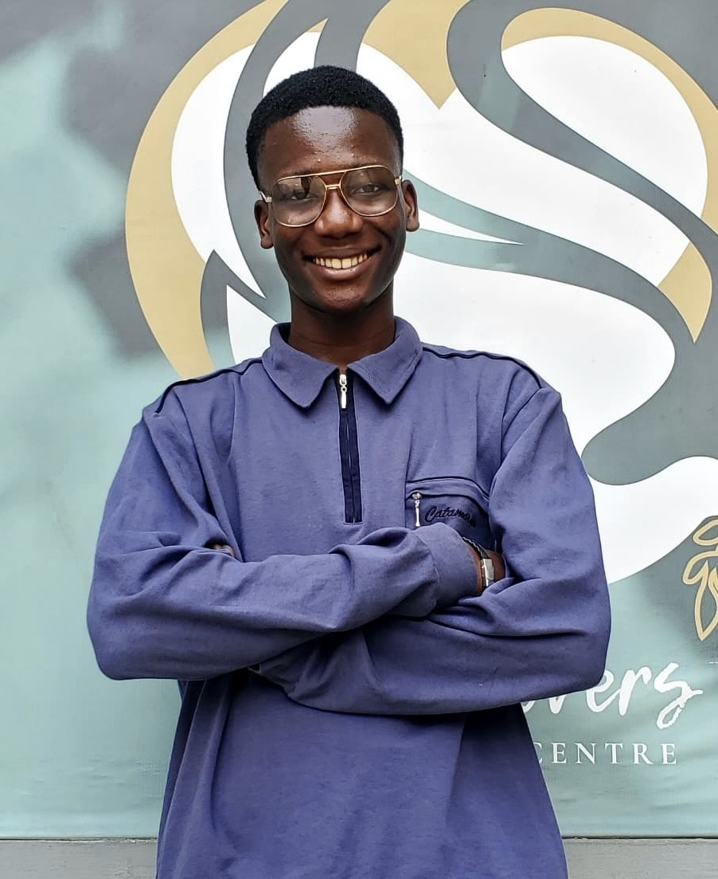

Alasela Babatunde
AI Engineer & Founder | Hackathon Winner | Building Emotionally Intelligent AI Systems
📞 Phone: 09154357208
📧 Email: alaselababatunde10@gmail.com
🔗 LinkedIn: Alasela Babatunde
💬 Discord: @alasela_babatunde
🐦 X (Twitter): @alasela_babs
📲 Telegram: @alasela_babatunde
🎥 TikTok: @alasela_babatunde
🌐 Website: https://alasela-babatunde.vercel.app/
💻 GitHub: https://github.com/alaselababatunde/Portfolio

Personal Summary
BioData:
- Name: Alasela Babatunde
- Age: 15
- Role: AI Engineer, Founder (Cura AI & Alash Studios), Educator, Mentor and Programmer
- Nationality: Nigerian
- Education: Stars College (High School), Graduating 2026
- Languages: English
AI Engineer and technical innovator with over 5 years of programming experience, starting at age 8. Currently serving as AI Engineer at Cura AI, Co. and Founder of Alash Studios. Proven hackathon winner with expertise in Python, HTML, C++, and advanced AI development tools including Flask, Langchain, Ollama, Hugging Face, and the OpenAI and OpenRouter SDKs. Specialized in building emotionally intelligent virtual companions for mental health support, AI-powered developer tools, and agricultural optimization systems. Built A.S.I.A., a functional AI assistant using speech recognition, TTS, and real-time animations. Recognized as Top 20 Finalist in national AI competitions. Active tutor, speaker, and project supervisor across youth-focused tech programs. Committed to creating ethical, impactful, and emotionally aware AI solutions.

Professional Summary
Technically skilled and mission-driven AI Engineer with deep experience in Python development, virtual assistant architecture, and real-world AI application. Currently serves as AI Engineer at Cura AI, Co., focused on building emotionally intelligent systems for mental health support. Proven track record in competitive development environments, including hackathon victories and national-level AI art competitions. Strong command of frameworks like Langchain, Flask, and LLM integration pipelines. Expert in Hugging Face ecosystem including model fine-tuning, AI agent deployment to Hugging Face servers, and comprehensive platform utilization. Proficient in API integration and documentation, enabling seamless system interoperability. Experienced in developing AI-powered tools for code debugging, auto-documentation, website building, and agricultural optimization. Skilled in mentoring students, simplifying technical concepts, and managing tech projects from planning to deployment. Public speaker and youth tech educator with hands-on contributions to programs aimed at early-stage learners. Currently developing solutions at the intersection of AI, mental health, agriculture, and responsible innovation.

Skills

Programming Languages & Frameworks
- Python | HTML | C++ | Flask | Object-Oriented Programming | GUI with Python

AI & Machine Learning
- OpenAI SDK | OpenRouter SDK | Ollama | Langchain
- Hugging Face (Model Fine-Tuning, Deployment, AI Agents)
- LLM Fine-Tuning for AI Agents Production
- Prompt Engineering | AI Ethics

Technical Specializations
- API Integration | API Documentation
- Virtual Assistant Development
- TTS & STT Synthesis
- Code Debugging AI Systems
- Auto-Documentation Tools
- Website Builder AI Integration
- AI Agent Deployment to Hugging Face Servers
- Model Deployment

Domain Expertise
- AI for Mental Health
- AI for Agriculture
- Generative AI Applications

Leadership & Soft Skills
- Project Supervision | Team Leadership
- Public Speaking | AI Debating
- Collaboration | Critical Thinking
- Mentoring & Teaching

Experience

AI Engineer — Cura AI, Co.
2025 — Present
- Serving as the AI Engineer for an early-stage startup focused on AI-driven mental health solutions.
- Leading development of emotionally intelligent AI systems and virtual companions.
- Architecting LLM-based applications for therapeutic support and user engagement.
- Implementing Hugging Face models and deploying AI agents to production servers.

Founder — Alash Studios
2023 — Present
- Founded and lead a Tech Studio focused on AI innovation and related technologies.
- Mentored and led small tech teams on project development and problem-solving.
- Overseeing multiple AI projects from conception to deployment.

AI Engineer — DevAssist Team (Remostart Hackathon Winner)
October 2025
- Won hackathon hosted by Remostart as part of DevAssist team.
- Developed AI-powered programming IDE with integrated chat interface for code debugging and auto-documentation.
- Built AI system for SME website builder, enabling automated web development with intelligent design suggestions.
- Handled all AI engineering responsibilities for both IDE and website builder products.
- Implemented natural language processing for code understanding and documentation generation.

AI Engineer — Team Astra (FutureStack GenAI Hackathon)
2025
- Competed in FutureStack GenAI Hackathon as AI Engineer for Team Astra.
- Developed AI solution to improve agricultural processes and optimize farmer productivity.
- Implemented machine learning models for crop prediction and resource optimization.
- Received Certificate of Participation for Team Astra.

AI Developer — Tech Disciples AI (Church Project)
2025
- Created custom AI assistant for Tech Disciples church community.
- Integrated AI-powered features to support community engagement and information access.
- Deployed chatbot system for answering community questions and providing resources.

Top 20 Finalist — Nigeria AI Digital Art Competition
2025
- Competed in national AI digital art competition hosted by Deakon College, Unistep, Goajo Team, and sponsors.
- Advanced to Top 20 finalists out of national participant pool.
- Created innovative AI-generated digital artwork showcasing creative AI applications.

Project Supervisor — Luca Ador
August 2024 — December 2024
- Oversaw multiple technology projects, ensuring timely completion and team coordination.
- Managed project timelines, resource allocation, and deliverable quality.
- Facilitated communication between technical teams and stakeholders.

Python Tutor and AI Speaker — Various Organizations
2024
- Taught Python programming basics and intermediate concepts at Digital Bootcamp and American Corner Ikeja.
- Delivered keynote Python programming workshop at Newton Academy, training over 100 students.
- Created curriculum and teaching materials for beginner and intermediate learners.
- Conducted hands-on coding sessions and provided one-on-one mentorship.

Developer — A.S.I.A (Virtual Assistant Project)
2023 — 2024
- Built a Python-based AI assistant using Speech Recognition, Text-to-Speech engines, and basic animations with PyGame.
- Implemented voice command processing and natural language understanding.
- Created visual feedback system with real-time animations for user interactions.

Education

Online Learning Platforms
- EdX: Python Programming (Beginner), AI With Python
- YouTube: Ollama, Langchain, Render, AI Agents Development, Deployment
- Coursera: GUI with Python, Generative AI, Problem Solving, Collaboration, AI for Everyone, AI Ethics, Object-Oriented Programming, Prompt Engineering
- Udemy: AIML Programming
- Stellar Academy: Cybersecurity
- SoloLearn: Python Intermediate, HTML Intermediate, C++
- ZionLight: HTML

Formal Education
- Stars College (High School) — Graduating 2026

Certifications
- Certificate of Participation — Team Astra (FutureStack GenAI Hackathon)
- Certificate of Achievement: The LLM Course (1) — Hugging Face
- Rasa Chatbot Development — Coursera
- Google AI Essentials — Coursera
- Appreciation Certificate — CLCC & Digital Bootcamp (AI Tutoring)
- Cybersecurity — Stellar Academy
- Python Intermediate, HTML — SoloLearn
- Object-Oriented Programming, GUI — Coursera

Awards and Recognition
- 🏆 Hackathon Winner — Remostart Hackathon (DevAssist Team) — October 2025
- 🥈 Top 20 Finalist — Nigeria AI Digital Art Competition — 2025
- 📜 Certificate of Appreciation — CLCC (AI Tutoring)
- 💻 Laptop & Scholarship Award — Boycode 3.0 for Excellence in Tech
- 🏅 "Tech Titan of Cohort 3.0" — Stellar Academy
- 👨‍🏫 Recognized Mentor to Upcoming Tech Professionals

Volunteer Experience
- Python Tutor at local community tech programs
- AI Education Contributor for youth initiatives
- Analytics Personnel — YPIT
- Publicity Team Member — GritinAI

Portfolio & Publications
- Personal Website: https://alasela-babatunde.vercel.app/
- GitHub Portfolio: https://github.com/alaselababatunde/Portfolio

Contact Information
📞 Phone: 09154357208
📧 Email: alaselababatunde10@gmail.com
🔗 LinkedIn: Alasela Babatunde
💬 Discord: @alasela_babatunde
🐦 X (Twitter): @alasela_babs
📲 Telegram: @alasela_babatunde
🎥 TikTok: @alasela_babatunde
🌐 Website: https://alasela-babatunde.vercel.app/
💻 GitHub: https://github.com/alaselababatunde/Portfolio

"Building AI solutions that are ethical, accessible, and impactful — proving that age is just a number when dedication meets innovation."

